Multipage Website Report: Practical Skills Assessment for COM109

Kanafa, Alicja.

B00812143.

Table of Contents

Initial Wireframe Design 3

Home page 3

About Us 3

Contact Us 4

Colour Scheme Selection 4

Design Process 5

Main page 6

About Us 6

Contact Us 7

HTML/CSS validation 8

Reference list 10

# Initial Wireframe Design

## Home page

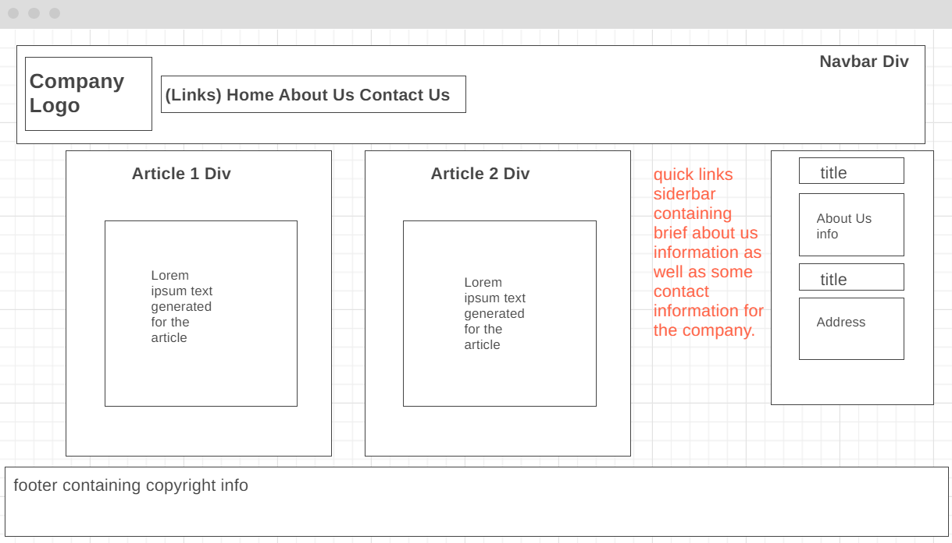

## About Us

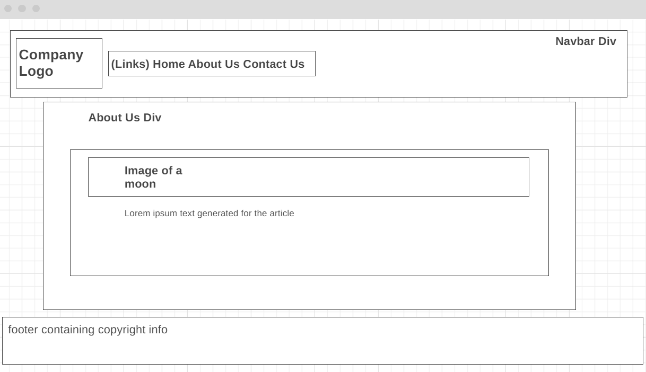

## Contact Us

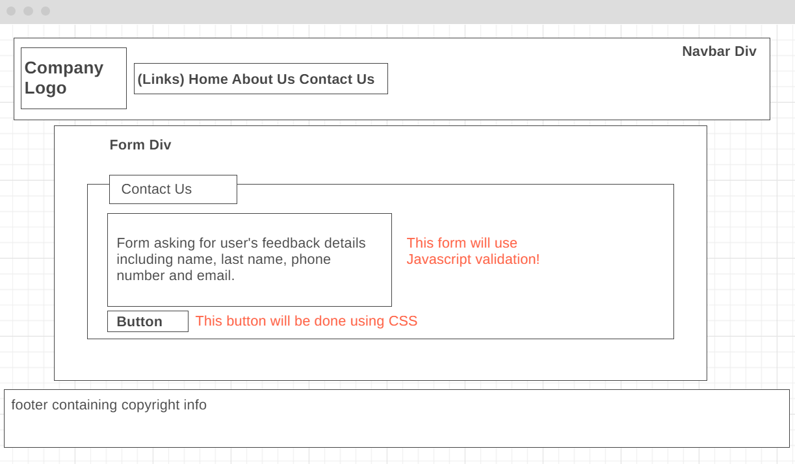

# Colour Scheme Selection

After careful decision making, I had decided the colour scheme that I would go for. Since the website that I have chosen to make is based on a company that gives sleep advice, I went for more muted colours to give a dreamier appeal. #C76883 would be used for hovering over a link in the navigation bar, while #C77D68 would be used for the active link in the navigation bar. #8B6D65 would be the footer’s background colour, and #E3D0F5 is the *Contact Us* form’s background colour. #E8E8E8 is responsible for default link colours in the navigation bar while #F9F9F9 is the default colour for the background of most elements, including the articles, sidebar and contact us section. #0E0E0E represents the main colour in the background.

# Design Process

When I was creating this website, I had it in mind to reduce the amount of scrolling that the user would have to do and instead I went for minimal scrolling, and a design that was user friendly and complied with accessibility for colour-blind users. For this, I asked a colour-blind friend to review my website and tell me whether my colour scheme was acceptable. The logo itself was made in Canva; a website that caters towards graphic design. It was exported as an SVG file to ensure that it scales properly on any monitor and reduces pixelation which can damage the overall aesthetic of the website.

To make sure that the user knows that they are on an active tab, I implemented the features of an interactive navigation bar at the top of the webpage. This means that when the user has clicked onto a new page, the navigation bar updates to reflect those changes:

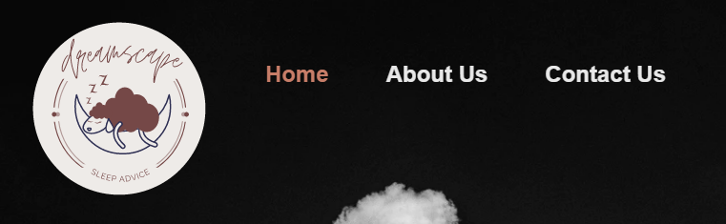 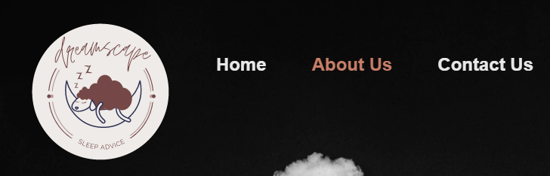

1: The navigation bar design

The main footer ties in with the colour scheme I have outlined above and is used to signal that the owners of this website are copyrighted holders of any information that they have give in the articles or even the *About Us* page:



2: Footer design

## Main page

I have designed the main home page with the intention of being straight to the point and displaying all the information on the one screen. I believe that this way, it captures the reader's attention much faster. The font that I have chosen for every page is a sans-serif font, meaning that it is easy to read for those who may be dyslexic or have a hard time with curvatures in font; further increasing accessibility. The headings are in bold and in italics to signify a new section and there is no overflow, meaning the page is static and will not scroll:

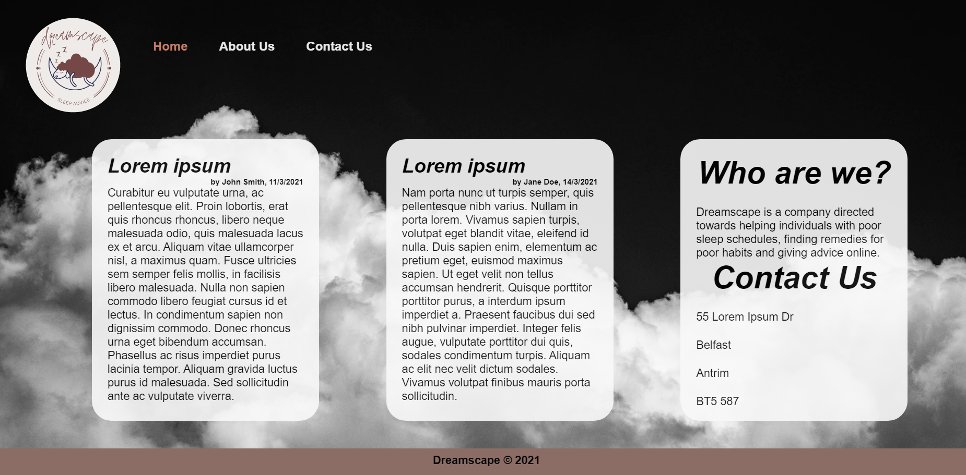

3: Home page design

## About Us

As for the *About Us* page, there is information about the company and what they stand for generated through lorem ipsum text for this assignment. Before the information provided to the visitor, there is an image of the moon to further symbolize the fact that this company is specific to sleep advice and relates to nighttime. I have ensured that this image remained in line with the colour scheme that I have chosen and contained alternate text so that a user’s screen reader could describe the image to them if needed, or if the browser is having a difficult time displaying the contents.

Like the main page, the main div element also has an opacity of 0.9, leaving it slightly transparent to reveal the clouds underneath. This was mainly an aesthetic choice, however I made sure that the element was still opaque enough that the text could be read even if its transparency is lower than the norm.

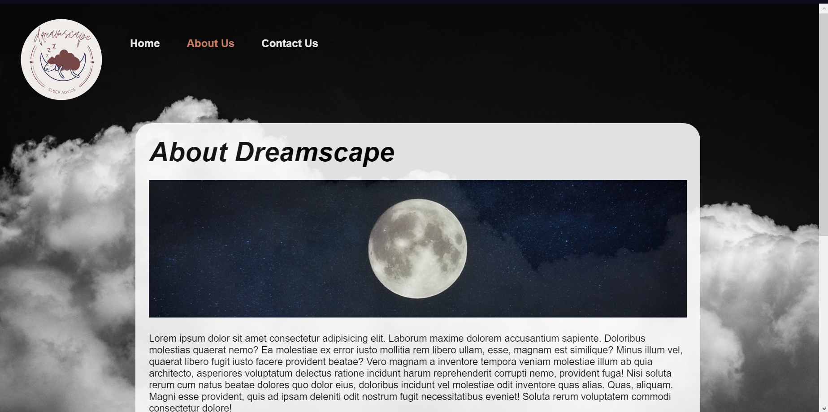

4: About Us

## Contact Us

The contact us form page was made in mind of keeping a dreamy aesthetic while maintaining its purpose of collecting feedback from the visitor. Again, the opacity has been turned down to 0.9, and this time the background is a soft purple color, as outlined by the color scheme. The form page also makes use of JavaScript validation rather than HTML validation to alert the user in case they have the wrong format for an email address, or they have left a field blank. The choice to use JavaScript was decided on since HTML validation does not work with every browser and I needed to keep users in mind who may have very old browser versions.

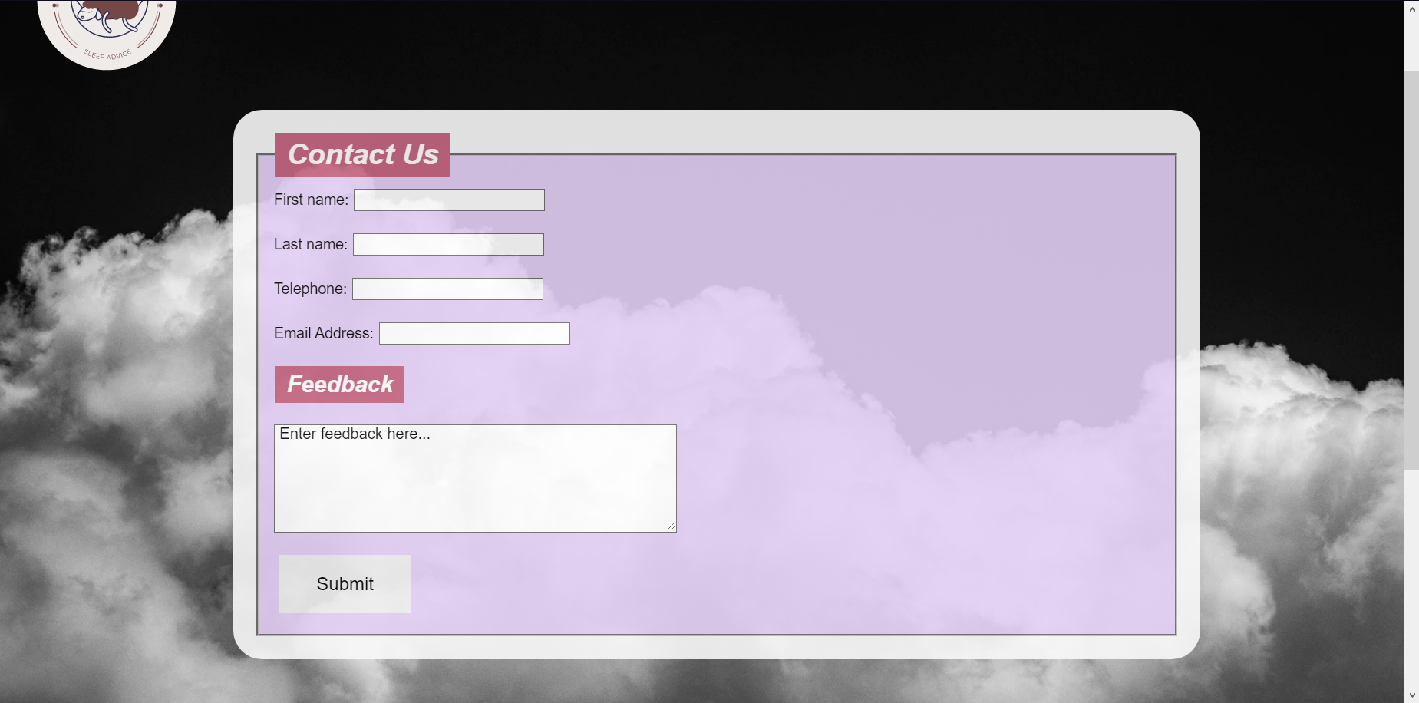

5: Contact Us Form

The validation was done through the popup alert boxes that are done through the browser, and it will repeat until the user has fixed the problem:

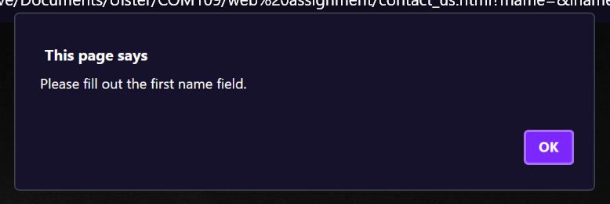

Lastly, the button that I had created was made using CSS and has a colour change when hovered over to signify that the user is clicking on a button.

# HTML/CSS validation

I made use of the W3C Validator to ensure that my website code was compliant with the standards. Unfortunately, there had been some errors picked up on by the validator which I will take into consideration and learn from next time I create a website. Here, you can see the validation for all 3 web pages as well as the CSS stylesheet that I had created to style the website:

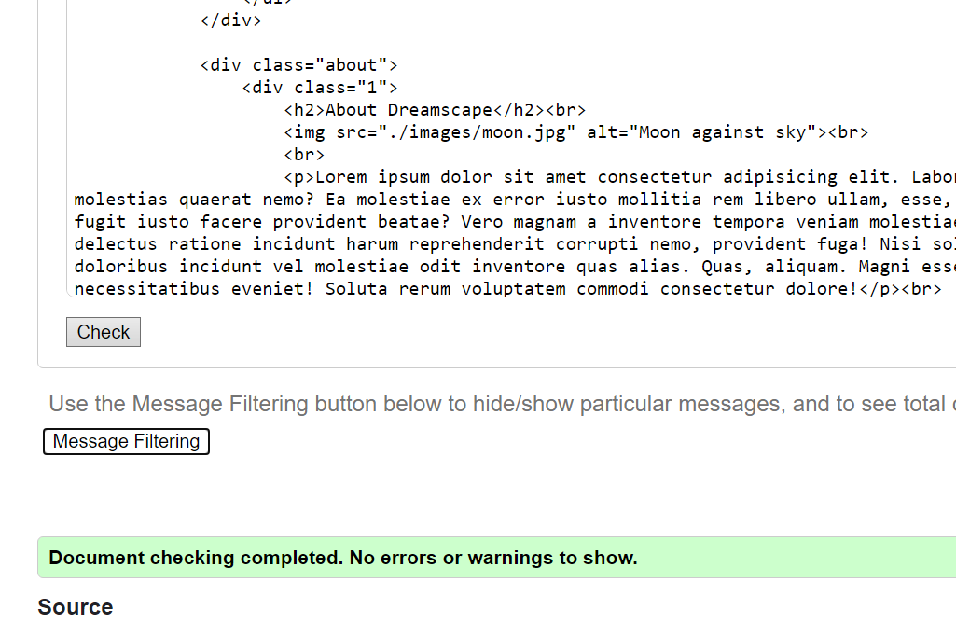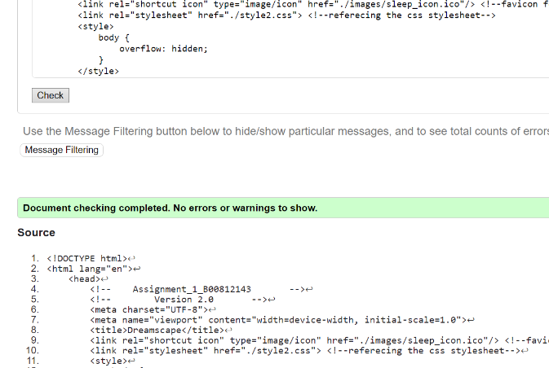

7: HTML validation for About Us page completed with no issues

6: HTML validation for main section completed with no errors

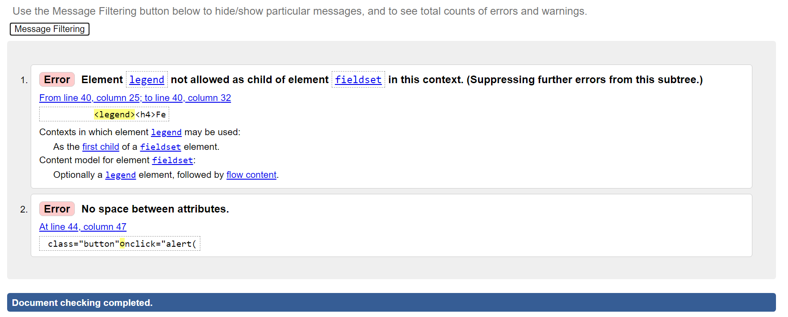

8: HTML validation for Contact Us page completed, with 2 errors

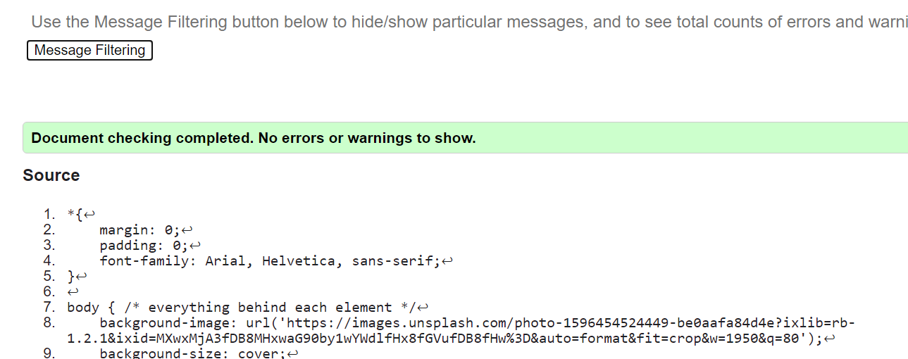

*9: CSS validation completed with no errors*

# Reference list

ColorHexa. (2012). *Color Hex - ColorHexa.com*. [online] Available at: <https://www.colorhexa.com/> [Accessed 11 Mar. 2021].

Delise, A. (2020). *Animated Navigation Bar Tutorial | HTML & CSS*. *YouTube*. Available at: <https://www.youtube.com/watch?v=5jWQVhJxU7c&t=530s> [Accessed 11 Mar. 2021].

Easy Tutorials (2019). *How To Make A Website Using HTML And CSS | Website Design In HTML And CSS*. *YouTube*. Available at: <https://www.youtube.com/watch?v=-2LtZRi6Q0s&t=484s> [Accessed 11 Mar. 2021].

Harding, O. (n.d.). *Clouds against a black sky*. *Unsplash*. Available at: <https://unsplash.com/photos/IWMXAfDayhw> [Accessed 11 Mar. 2021].

Mozilla.org. (2021). *CSS Grid Layout - CSS: Cascading Style Sheets | MDN*. [online] Available at: <https://developer.mozilla.org/en-US/docs/Web/CSS/CSS_Grid_Layout> [Accessed 11 Mar. 2021].

Nicholl, P. (2009). *Harnessing the Power of External Style Sheets.* [PowerPoint Presentation] COM109: Interactive Web Authoring. Available at: <https://learning.ulster.ac.uk/> [Accessed 3 Mar 2021].

Oelkers, F. (2016). *Moon against the Sky*. *Unsplash*. Available at: <https://unsplash.com/photos/e9rkZKjdlSc> [Accessed 16 Mar. 2021].

Ravi (2010). *How do I remove the horizontal scrollbar in a div?* [online] Stack Overflow. Available at: <https://stackoverflow.com/questions/4405954/how-do-i-remove-the-horizontal-scrollbar-in-a-div> [Accessed 16 Mar. 2021].

Refsnes Data (2015). *JavaScript Form Validation*. [online] W3schools.com. Available at: <https://www.w3schools.com/js/js_validation.asp> [Accessed 17 Mar. 2021].

Refsnes Data (2021a). *CSS Layout - Horizontal & Vertical Align*. [online] W3schools.com. Available at: <https://www.w3schools.com/css/css_align.asp> [Accessed 16 Mar. 2021].

Refsnes Data (2021b). *HTML button tag*. [online] W3schools.com. Available at: <https://www.w3schools.com/tags/tag_button.asp> [Accessed 16 Mar. 2021].

Refsnes Data (2021c). *HTML Entities*. [online] W3schools.com. Available at: <https://www.w3schools.com/html/html_entities.asp> [Accessed 16 Mar. 2021].

Refsnes Data (2021d). *PX to EM Conversion*. [online] W3schools.com. Available at: <https://www.w3schools.com/tags/ref_pxtoemconversion.asp> [Accessed 16 Mar. 2021].

Refsnes Data (n.d.). *HTML Background Images*. [online] www.w3schools.com. Available at: <https://www.w3schools.com/html/html_images_background.asp> [Accessed 11 Mar. 2021].